**EX NO: 11 The most frequent words in a text file**

**Date :**

**AIM**

Find the most frequent words in a text read from a file.

sample input 0: the peacock is the beautiful bird...

sample output 0: the

sample input 1: sea shells is in the sea shore

sample output 1: sea

sample input 2: It is a quite easy program

sample output 2: There are no frequently used words

**ALGORITHM**

**Step 1:** Get the filename as command line argument   
**Step 2:** Open and read the file content (text)  
**Step 3:** Split the text into words with space delimiter ‘ ‘  
**Step 4:** Create the dictionary with the count for each word in the text.  
**Step 5:** Findthe word with the maximum count and print the word

**FLOWCHART**

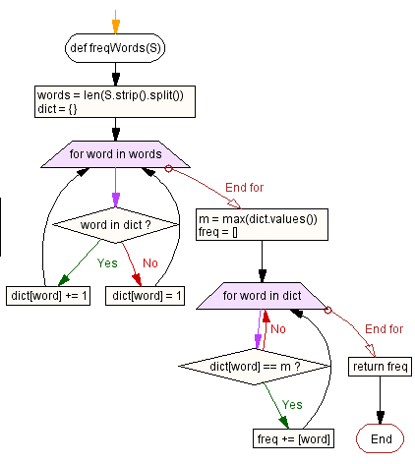

**SOURCE CODE**

import sys

def freqWords(S):

words = len(S.strip().split())

dict = {}

for word in words:

if word in dict:

dict[word] += 1

else:

dict[word] = 1

m = max(dict.values())

freq = []

for word in dict:

if dict[word] == m:

freq += [word]

return freq

filename = sys.argv[1]

try:

f = open(arg, 'r')

text = f.read()

print(wordcount(text))

f.close()

except:

print("File not available!")

**OUTPUT**

sample.txt

python is great language

$ python3 wc.py sample.txt

**4**

**RESULT**

Thus the python program for finding the most frequent words in a text read from a file was executed and verified successfully.